The West Has a Resentment Epidemic

Across the West, the main trigger of populism has been the growing inequality—and hostility—between urban and rural regions.
BY ROBERTO STEFAN FOA, JONATHAN WILMOT
SEPTEMBER 18, 2019, 4:31 PM
In 2014, the Hill newspaper rated Minnesota the second-most-liberal U.S. state. For decades, Minnesotans had reliably supported Democrats in the House, in the Senate, and for the presidency—in Ronald Reagan’s landslide presidential reelection of 1984, it was the only state in the country to support his opponent, former Minnesota Sen. Walter Mondale.
Yet in 2016, America’s second-most-liberal state did something unexpected. As the presidential campaign rolled on, Donald Trump picked up a surge of support, drawing level with his Democratic rival, Hillary Clinton. In the end, Trump bettered Clinton in 78 of the state’s 87 counties. While Clinton eked out a narrow victory in the state by a 45,000-vote margin, it came almost entirely from the state’s largest city, Minneapolis.
On the morning of Nov. 9, 2016, progressives in Minneapolis woke up to find themselves on a lonely island of liberalism amid a sea of Trump-supporting counties. Drive 100 miles in any direction, and you’d be in Trump country. Keep driving, and you still would be.
Minnesota may have been an extreme case, but it was not alone. A driver could leave New York City on Interstate 80 and cross only a handful of Democrat-voting counties before arriving at Los Angeles, 2,451 miles away. Break down the election results by county, and one fact becomes obvious: Progressive America forms an archipelago of cities, scattered across the East and the West coasts.

Votes for Donald Trump in the 2016 U.S. Presidential Election
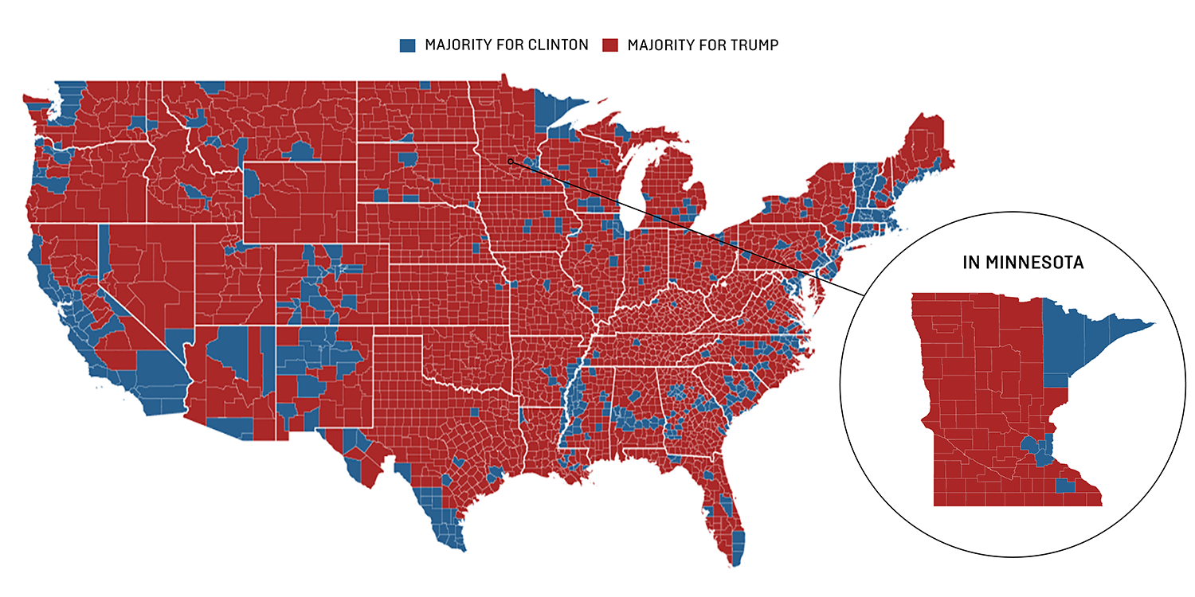
SOURCE: MCGOVERN (2016)

The results of the 2016 presidential election in the United States illustrate a broader reality, which is that the gap between the cosmopolitan city and the economic periphery has become the new social class divide across the West. Where people live, as much as how they live, now increasingly determines their beliefs, values, and sense of tribal belonging.
As the researcher Will Wilkinson explores in a recent report, such a “density divide” is not exclusive to the United States. It can also be found in the results of the 2016 British vote on membership of the European Union, where support for remaining in the EU was largely concentrated around London and its extended commuter belt, and the 2017 French presidential election, where support for the left-center candidate Emmanuel Macron clustered around the thriving cities of Paris, Lyon, and Toulouse.
Changes in the global economy have spatially sorted voters into progressive urbanites with a large stake in a new technological future, globalization, and liberal values, and the left-behind who see their own identity and economic prospects threatened as never before. Rural areas and small towns may have always been more culturally conservative, but this divide, combined with the resentment generated by economic and wealth inequality, has triggered the most prominent recent political explosions across the West.

The Geography of Populism in Britain and France
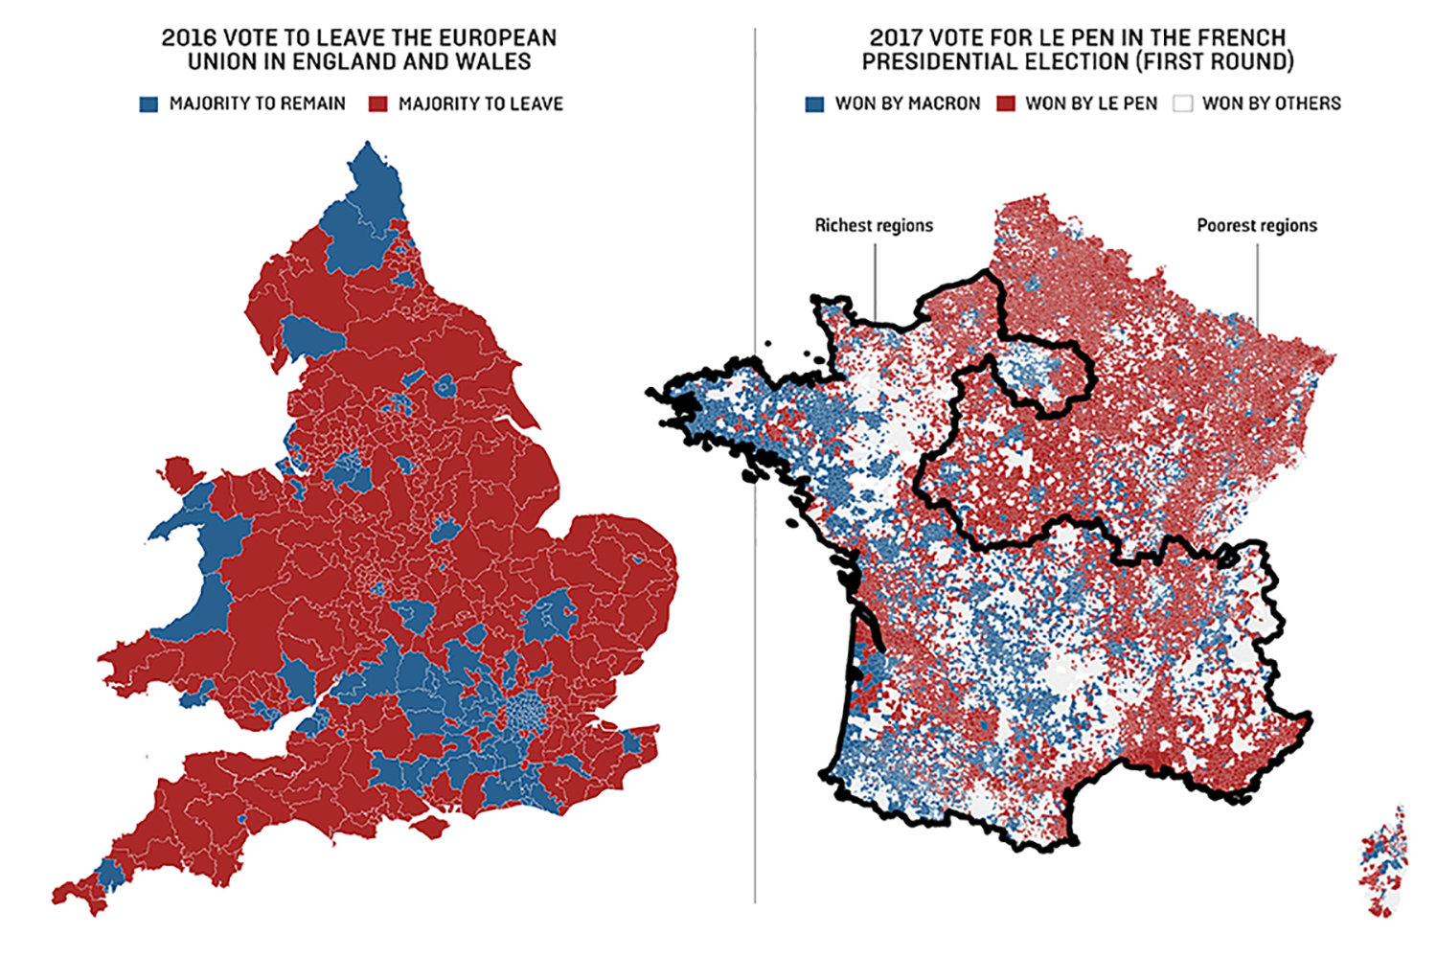
SOURCE: HOUSE OF COMMONS LIBRARY, FRENCH MINISTRY OF THE INTERIOR

The Roots of Regional Resentment: Globalization, Crisis, and Austerity
While much attention has focused on differences in values between progressive cosmopolitanism and provincial conservativism, the fact remains that conservative values, at least on matters of lifestyle and religion (if not on matters of national identity), are either stable or in decline. This makes the populist insurgency an anomaly, for a constant cannot explain a change.
What has changed in the last generation, however, is the level of economic and wealth inequality between regions of Western countries. As Joan Rosés and Nikolaus Wolf have shown, regional divergence began in the 1980s with globalization and deindustrialization, and it has deepened in recent years.
If we are to understand the depth of populist anger, we must look to the economics of regional resentment. In the United Kingdom, for example, a person’s position on leaving or remaining in the EU in the 2016 referendum was linked to the geography of the nation’s housing market, with research showing that property prices are one of the best predictors of whether voters supported or opposed Britain’s vote to leave the EU, even at the ward level (the smallest electoral unit, of around 5,000 to 6,000 voters). Estimates by Chris Hanretty, which we have mapped below, show that Remain constituencies were almost entirely concentrated around London and its satellite commuter towns, while Leave constituencies covered almost the entire rest of England.

Wealth Inequality, the Brexit Vote, and the Aftermath
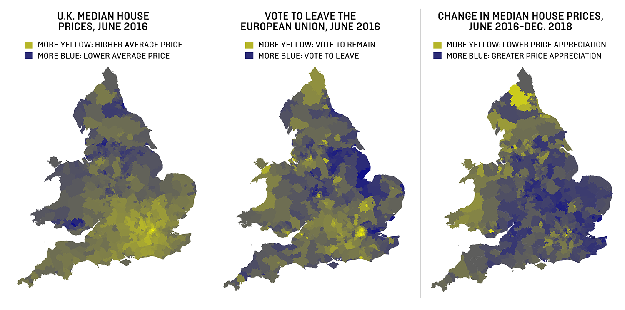
SOURCE: HOUSE OF COMMONS LIBRARY

Meanwhile, new OECD data shows how in France, the regions that voted for Macron in the first round of the 2017 French presidential election—the areas around Paris, Toulouse, and Brittany—were those in which the economy grew fastest since the launch of the euro. Many areas voting for the right-wing candidate Marine Le Pen, such as the Grand Est, experienced no net income growth at all during those decades.
In short, behind the bluster and rhetoric of populist discourse there lies a deeper emotion: resentment. Resentment is difficult to measure, for it always expresses itself indirectly. It is easier to target the objects of resentment for perceived or imagined moral failings than because they are wealthier or more fortunate in life. Resentment is a conflict in search of a cause—a cause that populists readily provide.

Why Now?
Thinking in terms of the new regional class divide also solves one of the perennial mysteries of the populist wave in Europe and the U.S.: Why is the disruption happening now, rather than a decade ago, at the height of the global financial crisis? The answer emerges very quickly when looking at how different regions have recovered—or not recovered—in the decade since.
While the crisis proved only a temporary setback for cosmopolitan cities such as London, Amsterdam, and New York—whose financial sectors were bailed out by government largesse—blighted ex-industrial regions continue to struggle under the burden of austerity. In the decade from 2008 to 2016, while GDP per capita rose over 13 percent for California and New York, it rose on average less than 3 percent across other U.S. states. While GDP per capita rose over 6 percent in Greater London, they rose by only half that in the rest of the U.K., and while per capita GDP recovered in Greater Paris by 3 percent, in the rest of France incomes did not grow at all. It is a pattern found across Europe, from the Netherlands to Sweden to Denmark, Italy, Ireland, and Greece. Wealthy, cosmopolitan cities surge ahead, and the periphery gets left further and further behind.

The First Will be First: GDP per Capita Growth Since the Crisis.
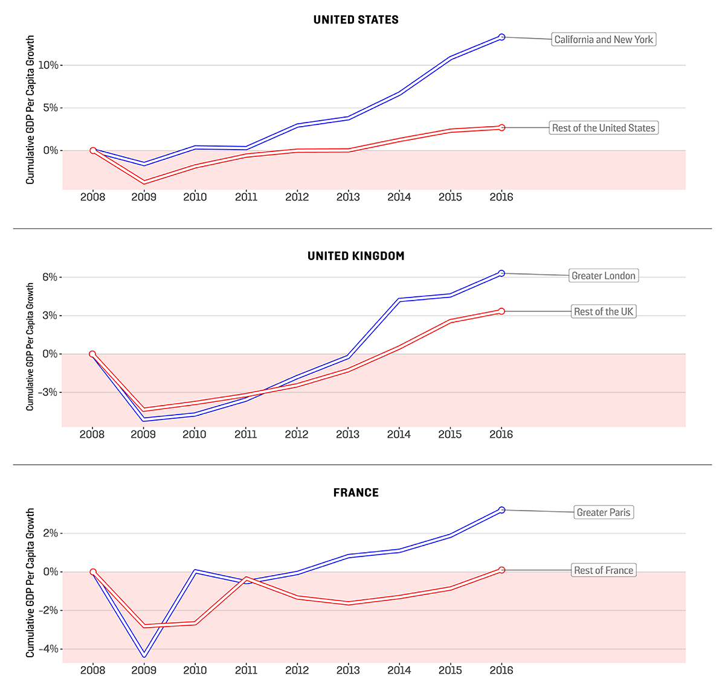
SOURCE: OECD

Over the past 10 years, it has been this combination of rising urban wealth with government neglect for peripheral regions that has fueled populist resentment by combining material hardship with a sense of injustice. While prosperous cities were bailed out, poorer regions have been subject to death by a thousand cuts as government belt-tightening has slashed local budgets and starved regions of capital investment.
In the United States, then-Treasury Secretary Timothy Geithner made the rescue of the banking system the centerpiece of President Barack Obama’s economic legacy, while both Treasury and Congress conspired to starve states of the funds required for necessary public investment. From 2008 to 2016, government investment as a percentage of GDP in the United States sunk to its lowest level since records began in 1947, as infrastructure budgets that had once connected the country with highways, airports, and bridges were slashed. It should be no surprise that when Trump promised to stop spending money overseas and to start rebuilding U.S. infrastructure, he found support in Democratic heartlands, in places with potholed roads and crumbling bridges, where Republicans had never found support before.
In the United Kingdom, the government of Conservative Prime Minister David Cameron and his chancellor, George Osborne, also proved the perfect lightning rod for feelings of regional resentment. With their elite backgrounds at Eton, the University of Oxford, and London’s exclusive Notting Hill neighborhood, they symbolized the interests of the capital’s cosmopolitan elite, a fact that added insult to injury as they slashed spending for marginal towns and villages. The Brexit vote of 2016 crossed party lines, bringing together rural Conservative voters with left-behind working-class voters from northern English Labour heartlands to spurn the interests of Britain’s global metropolis.
Finally, in continental Europe, the eurozone crisis has galvanized resentment between countries as austerity in Southern Europe has been prolonged by German refusal to soften the Stability and Growth Pact, even as the cost of government borrowing reaches record lows. When Italy’s populist firebrand Matteo Salvini blamed the EU for a bridge collapse in Genoa that killed 43 people, it was not as absurd a claim as it appeared. Behind the collapse lay years of budget cuts made in order to meet the terms of eurozone membership—cuts that would not have been made if Italy could borrow in its own currency, and accept instead the inflationary consequences.
While there is more to regional policy than public-sector investment, it is key to regional inequality. The presence of crumbling roads and bridges, as well as shuttered post offices and railway stations, offer a concrete reminder of a region’s neglect and abandonment. And the size of regional infrastructure spending shows a government’s commitment to redistribute growth from the economic center to a periphery that is ever more dependent upon state support.

Gross Public-Sector Investment, in Real Local Currency Terms, in 2008
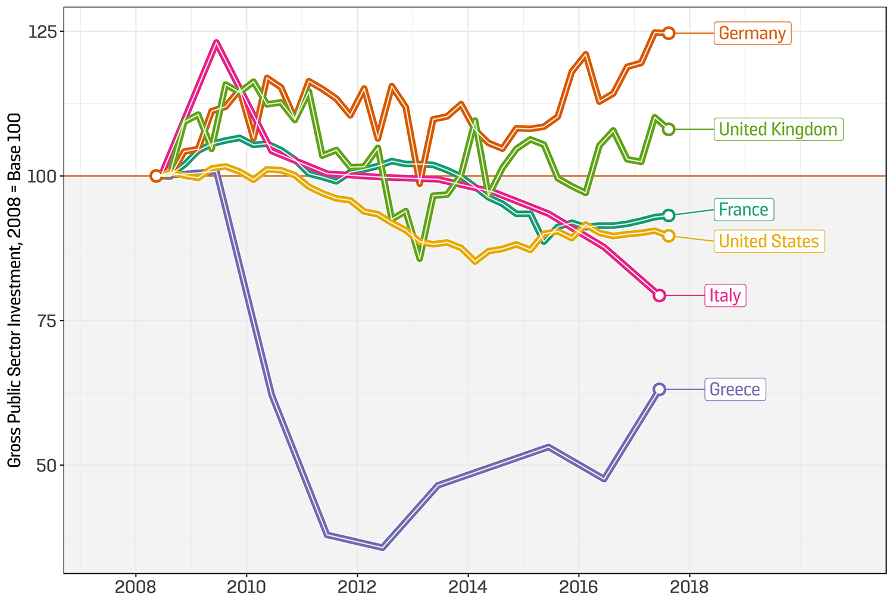
SOURCE: REFINITIV (QUARTERLY DATA); WORLD BANK AND OECD (ITALY, GREECE)

Viewing contemporary politics as a clash between the cosmopolitan center and the regional periphery also solves another of the mysteries of the populist wave: Why did populists sweep to power across Central and Eastern Europe, despite two decades of robust economic growth?
The answer is that there’s been growth for some—but not for others. In the Czech Republic, for example, GDP per capita in Prague grew by over $20,000 from 2001 to 2016—almost as much as the total GDP per capita for the country overall. In 2013, Milos Zeman swept into the Czech presidency on a populist platform that won him widespread support in every region except for the capital. He repeated the same feat again last year.
In Hungary, meanwhile, the GDP per capita gap between Budapest and the rest of the country rose from double in 2001—already a huge difference—to two and a quarter times by 2010, when Viktor Orban swept to power on a populist, anti-establishment platform that explicitly targeted the Budapest political and social elite. Interestingly, however, by the time of Orban’s reelection in 2015, the gap had narrowed somewhat, with Orban dishing out workfare to supporters in remote villages and towns while doing less to attract investment to the capital. Orban understood something that his liberal opponents had not: For all the newfound wealth of the capital, there were more votes to be had among the underemployed, the asset-poor, and the resentful in the regions.

Breaking the Cycle
As long as regional inequality persists, the populist pressure is very unlikely to abate. As soon as one threat recedes—the possibility of a Le Pen presidency, for example—another one comes to replace it, such as the yellow vest protests. No sooner had the UK Independence Party (UKIP) collapsed following its success in the 2016 referendum, that a revived Brexit Party gained the most seats in the European elections. And while Trump has—at best—only a 50 percent chance of winning the next U.S. presidential election, the sheer resilience of his support across the U.S. heartland—with a solid 40 percent of American voters consistently approving his performance in office—suggests that a cycle of right-wing populism that previously sustained the Tea Party and Sarah Palin is unlikely to end for good when his first term does.
That means coming to terms with populism—and coming to terms with the causes of populism.
Alas, many progressives in the United States seem to have opted instead for denial, either blaming Russian intervention or concluding that populism is due simply to a “basket of deplorables,” to borrow Hillary Clinton’s infamous phraseology. With current democratic politics deemed unworkable, some commentators suggest tilting the system through court-packing, abolition of the electoral college, or encouraging “bureaucratic” politics (alternatively stated: unelected officials disobeying elected ones).
The real tragedy here is that such tinkering ignores even Clinton’s own speech, which went on to describe another “basket” of people who feel that “the government has let them down, the economy has let them down, nobody cares about them, nobody worries about what happens to their lives and their futures” and called for progressives to do more to understand and empathize with their plight, rather than engage in demonization and point-scoring.

Bridging the Divide
Elsewhere, there are signs of a more mature approach as figures from the political establishment attempt to defuse and disarm the underlying mechanisms of populist rage.
In the United Kingdom, for example, the new Prime Minister Boris Johnson—an establishment figure in populist garb—has made infrastructure and regional policy a priority, voicing his support for high-speed rail to connect the country’s northern cities and expanding his predecessor’s pledge to support “left-behind towns” with a promised 1.6 billion pounds in funding, about $2 billion. A genuine rebalancing of growth across Great Britain would go a long way toward mollifying the anger that led to the Brexit vote of 2016 and detoxifying the resentments that have built up over a generation of unequal development between north and south.
We have also seen it in France, where the government of Emmanuel Macron—the erstwhile “president of the rich”—has implemented a sharp U-turn on its earlier austerity drive, reversing a controversial fuel tax that would have disproportionately affected voters in poorer rural districts, and it is now committed to, in his own words, “better public services outside major cities, both in terms of the number of civil servants and infrastructure.” Having embraced stimulus at home, Macron’s new mission is to secure European support for reform of the growth and stability pact, a longstanding demand of populists in Italy, Greece, and Spain.
To give credit where credit is due, in the United States, one or two moves by the Trump administration have helped to rebalance growth, including the placing of a cap on the federal tax deduction for state and local taxes, and a reduction of the mortgage interest tax deduction, both of which had benefited wealthy residents in coastal states over poorer residents in the U.S. heartland. Yet it is likely to fall to a future administration to overturn the legacy of years of declining public investment and neglect.
A proposal for a bold new round of public investment to reconnect forgotten Americans—whether packaged as infrastructure for growth or as a Green New Deal—presents the most optimistic prospect for bringing America’s cosmopolitan cities together with its struggling inland regions. While the Green New Deal is still dismissed by many as a progressive pipe dream—free money for “bullet trains to nowhere,” as California’s high-speed rail project has been dubbed—it could become a genuinely bipartisan project to rebuild roads, railway lines, and cities, and to reintegrate America’s forgotten economic hinterland with its prosperous, progressive coasts.
In short, to face the populist challenge, progressives need to build bridges, both real and metaphorical. Otherwise, as the electoral map shows, they will continue to find themselves living adrift on small islands of prosperity, while the tide of populist anger continues to rise.

