Week_6_bonus
Jack Kerouac
The Beat Generation
“The word beat originally meant poor, down and out, dead-beat, on the bum, sad, sleeping in subways. Now that the word is belonging officially it is being made to stretch to include people who do not sleep in subways but have a new gesture, or attitude which I can only describe as a new more. Beat Generation has simply become the slogan or label for a revolution in manners in America.” (Kerouac, Beatific: The Origins of Beat Generation, 1959).
For more information, please see
- Raskin, Jonah. American Scream: Allen Ginsberg’s Howl and the Making of the Beat Generation. Berkeley: University of California Press, 2004.

- the USA of the 1940s and the 1950s supplied the context for the Beats, i. e.
Jack Kerouac, Allen Ginsberg, Lawrence Ferlinghetti, William Burroughs, Gregory Corso, John Clellon Holmes, Gary Snyder, Michael McClure, Phil Whalen, John Wieners, and others

- the Great Depression of the 1930s had shaped the childhoods of most of the Beats
- American involvement in WWII and the atomic bombings of Hiroshima and Nagasaki in 1945 = these events had a profound effect on the counterculture of the following years

What did the situation look like in the 1950s?
- domestically: rapid improvement in economic conditions, economic confidence, consumer durables, cars, TV sets, industrial corporations + McCarthyism (senator Joseph McCarthy (1908–1957, R, in office 1947–1957 for Wisconsin) led a campaign of intimidation that resulted in the “outing” of hundreds of individuals with real or alleged ties to communism
- What do you know about Julius and Ethel Rosenberg?
- the birth of baby boomer generation

- abroad: cold war, anti-Sovietism, isolationism, Korean War (1950–1953)

- presidents:
Dwight Eisenhower (1953–1961, R)
John F. Kennedy (1961–1963, D)

- two basic texts of the Beat Generation:
Allen Ginsberg’s collection of poems Howl and Other Poems (1956)
Jack Kerouac’s novel On the Road (1957)
- Howl and On the Road were responsible for bringing the Beat Generation to the attention of a mainstream society/readership
- both books were published in the mid-1950, in the middle of Eisenhower’s presidencies
- Kerouac’s works were much more successful than the books by other Beats, so they are often regarded as facts
- please, do not forget Kerouac’s works are not historical facts but works of fiction
- the range and diversity of Beat literary production == influence on second-generation Beats such as Bob Dylan
- *dissonant voices: acting, music, painting
- examples:
acting Marlon Brando (1924–2004) = an archetype of the Beat-made-good
The Wild One (1953, road movie/Divoch); an image of the alienated youth
- music: bebop, rock-and-roll; painting: abstract expressionism (Jackson Pollock)
- the Beat Generation was more of a social than a literary movement
- the Beat bases were in New York and San Francisco and served as artistic retreats for young people sharing a sense of alienation from the values dominant in post-war America
- an important event: Kerouac and Ginsberg first met in 1944 in Columbia (Ginsberg was of Jewish origin; Ginsberg was a poet; Kerouac was a prose writer = there was no rivalry in the literary production)
- the core of the Beat Generation: Kerouac, Ginsberg and Burroughs
- according to Matt Theado (2000, 17), a Columbia student Lucien Carr was said to have introduced Kerouac to Ginsberg and Burroughs; on August 14, 1944, Carr stabbed his friend David Krammerer to death and Kerouac was a material witness; his father refused to pay bail, so Kerouac accepted his girlfriend’s offer = his family would lend him $100 if he marries her; having paid bail, Kerouac was released from prison; he got married shortly afterwards
Summary
- the Beat Generation = a product of and a reaction against the stifling conformity of the Eisenhower’s presidency of the 1950s
- the original Beat circle occurred on the Columbia campus in the spring of 1944
- in 1954, Ginsberg relocated to San Francisco
What do you know about the Beat Generation?

Jean Louis Lebris de Kerouac (1922–1969)

- was born and brought up in the industrial town Lowell, Massachusetts
- the son of French-Canadian immigrants
- came from the working-class background
- Kerouac recounted his parents’ careers in his first novel The Town and the City (1950, Maloměsto, velkoměsto)
- it is essentially an autobiographical novel
- it was published under the name Jack Kerouac
- it had been written before Kerouac developed his distinctive style of writing, which can be seen, for example, in his novel On the Road (1957)
- it is set in New York and a small town of Galloway, Massachusetts
- Galloway represents Kerouac’s home-town Lowell
- the main hero Peter Martin struggles for success in a university football team
- Kerouac himself moved to Columbia in September 1940 on a football scholarship
- Kerouac was supposed to be a halfback
- unfortunately, he fell out with his football coach, broke his leg, and failed some courses
- in result, he abandoned his degree, which made his father really unhappy
- Kerouac and other Beats dashed their parents hopes that they would enact their parents’ visions of the American dream
- in the novel The Town and the City, a character named Leon Levinski represents Allen Ginsberg(!)

- interestingly enough, there was no black community in Lowell, which Kerouac highlighted in his description of an athletic “African American” girl in his work Maggie Cassidy (1959, Maggie Cassidyová)

- Kerouac dropped out his university studies at Columbia University
- in 1942, Kerouac, “signed up for the merchant marine and shipped out aboard the U.S. Army Transport ship Dorchester” (for more info, please see http://www.openculture.com/2013/01/jack_kerouacs_naval_reserve_enlistment_mugshot_1943.html)

https://www.archives.gov/publications/prologue/2011/fall/kerouac.html

- he was discharged for psychiatric reasons
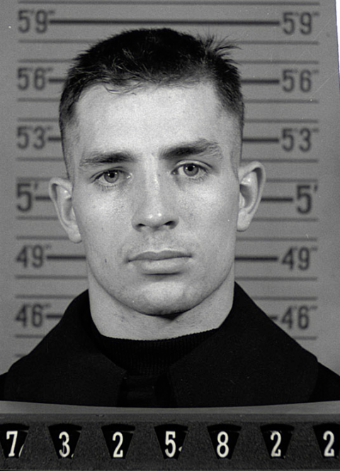

Springer, Mike. Jack Kerouac’s Naval Reserve Enlistment Mugshot, 1943. 24 January 2013. Open Culture. http://www.openculture.com/2013/01/jack_kerouacs_naval_reserve_enlistment_mugshot_1943.html. Accessed 22 March 2020.
- in October 1955, Kerouac took part in the Six Gallery Reading
- it was a gathering of underground poets and writers from the East Coast (Kerouac, Ginsberg, Ferlinghetti) and from the West Coast (Snyder, Whalen, Lamantia)
- as Raskin observes (2006, 9), it “was a festival of cross-continental and cross-cultural pollination. East met West. The urban poets who had been shaped by the culture of New York – the epicentre of American arts and letters in the 1940s and 1950s – met and mingled with their contemporaries who had been shaped by the culture of the western edge of the continent.”
- it took place in San Francisco
- San Francisco inspired Kerouac to write his first book of poetry San Francisco Blues
- it was written in 1954
- it comprises 80 choruses

- between 1950 and 1957, Kerouac was drinking (too) much, he was smoking marijuana, taking Benzedrine, and trying morphine with his friends (then returning to his mother who would take care of him)
- Kerouac and his mother had a steady relationship (perhaps Oedipal?)
- in September 1957, his novel On the Road was published – please see a handout
- it is an adventure story set in the late 1940s
- two men who travel in cars from coast to coast (enjoying women, marijuana, and jazz)
- Sal Paradise
- a linear narrative

- Kerouac second popular novel The Dharma Bums (1958, Dharmoví tuláci)
- builds on a number of spiritual themes
- there are more than 20 references to God and Jesus
- the theme of spiritual enlightenment
- the main hero Ray Smith tries to understand and assimilate theoretical and practical aspects of Buddhism
- a possible connection to Kerouac Catholic upbringing

What is the Beat Movement or the Beat Generation?
When did it originate?
Where did it centre?
What did they advocate?

- make up your own definition
- the 1950s
- San Francisco, Los Angeles, New York
- personal release, purification, and illumination achieved through drug experiments, sex, Zen Buddhism, etc.

